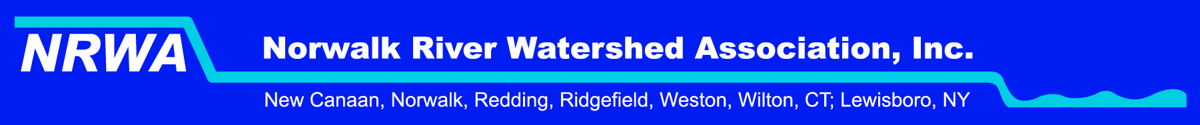

September 22, 2017

Dear Public Utility Regulatory Authority:

I am writing on behalf of the Norwalk River Watershed Association to express our concerns about the very little information we have on the proposed acquisition of Aquarion by Eversource. We are concerned about the many potential conflicts of interest that will arise when the interests of power and water providers inevitably intersect and conflict. Will this giant utility choose to protect water quality or be tempted to sacrifice water protections in order to keep the cost of power lower and more competitive? Because water is used in energy production, such as for hydropower, for fracking and for cooling power plants, for example, and because water can be contaminated by leaking fuel lines that cross the state, and for many other obvious reasons related to such conflicts of interest, we believe it is vital that these two enormously important utilities remain separate.

What will the state’s regulation and oversight be of this private company? How will such oversight be funded in Connecticut? The union of a water and power utility is unprecedented in our state. The Norwalk River Watershed Association requests that the citizens of Connecticut be provided more analysis and information about how such a sale will potentially affect the supplies of energy and water that we depend on. We would like to know how water quality and water flows will be protected if the sale were to take place. We strongly oppose this sale at this time on the grounds that such a sale seems likely to threaten water quality and water supplies in our state.

Sincerely,

Louise Washer, President
Norwalk River Watershed Associaiton

