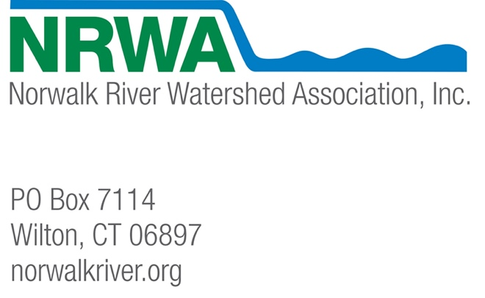

August 18, 2021

To: Thomas Morgart, State Conservationist
Kristin Walker, Civil Engineer
Natural Resources Conservation Service

Re: Comments on the Norwalk River Dam #2 Rehabilitation Project

Dear Mr. Morgart and Ms. Walker,

I am writing on behalf of the Norwalk River Watershed Association (NRWA), which represents over 2,000 participants in the seven watershed towns of Ridgefield, Wilton, Norwalk, Redding, Weston, New Canaan, and Lewisboro, NY regarding the proposed Norwalk River Dam #2 Rehabilitation Project.

Thank you for the thorough report on the proposed project and for the chance to submit these comments. NRWA supports the plan to decommission the dam by removing the spillway and embankment down to the valley floor and reconnecting the Ridgefield Brook stream channel and floodplain as well as the plan to protect the stream bed from erosion and to ensure maintenance of the current water and sediment capacity of the Great Swamp wetlands.

However, we would like to request that the NRCS consider improving upon the proposed plans to install a concrete cut-off sill and a 10’ x 69’ section of rip rap-armored channel. While this approach does achieve the very important goal of protecting the upstream resources associated with the Great Swamp, we ask that the NRCS consider ways to carry out the restoration in a more nature-based way.
For the concrete cut-off weir, there is a risk that the downstream profile could degrade, and the weir could form a complete barrier to aquatic passage. Since protecting the upstream resource of Great Swamp is a priority, certainly alternatives to the concrete weir would need to be weighed against that risk. A more permeable alternative, however, such as a buried stone sill, holds the potential of protecting the swamp while also maintaining continuity in hyporheic exchanges through the corridor.

As the NRCS report states, “although the dam could pose a potential barrier to some 37 fish species attempting to move upstream, CT-DEEP fisheries concluded that there are ‘scant fisheries resources in this area of the watershed’ and attempting to add fish passage is not appropriate” (page 54). It is clear, though, that the area’s fish populations have been impaired due, in part at least, to the presence of the dam and dams down-river. Removal of the dam and restoration of the area could and should provide natural habitat features such that returning healthier fish populations are possible in the future.

Save the Sound, Trout Unlimited, the town of Wilton, and several individual landowners in our watershed are working together right now to remove dams in the watershed. The recent removal of the Flock Process dam by the city of Norwalk and of the Cannondale Dam by TU and others have already resulted in the return of anadromous fish, American eel, and even lamprey eel along with at least one native aquatic plant species that requires free-flowing waters. TU and NRWA are working with two property owners to remove small dams in Wilton and are continuing to reach out to more dam owners and offer help with removals and restoration. Work to remove the Dana Dam at Merwin Meadows in Wilton is slated to begin soon.

These groups working together in the watershed are focused on aquatic connectivity because it is crucial to creating healthy habitat for aquatic life and for making aquatic systems more resilient and adaptable to change. We would like to see the Norwalk Dam #2 project help support these goals.

We also request consideration of a nature-based alternative to the armored channel which would provide some degree of velocity and depth diversity to help support aquatic passage. A more natural channel design could be accomplished by simply constructing a less uniform channel by installing boulder clusters to create resting habitat or by reshaping the cross-section to form a multi-stage channel, or a combination of the two. There are many such strategies for natural stream restoration proposed in the NRCS Guidance for Stream Restoration (2013) (https://www.nrcs.usda.gov/Internet/FSE_DOCUMENTS/nrcs144p2_062267.pdf).
This guide states that “the use of rip rap should be minimized, since rip rap can impair vegetative growth and ecologic function for many decades,” and that
“bed stabilization structures can act as substantial barriers to some types of aquatic life passage” (pages 46- 47). It adds that, “in general, fish need appropriate physical habitat, water quality, and flow to thrive. The lack of longitudinal complexity (riffles, runs, pools and glides) is a common physical impairment for cold-water fishes” (page 51).

Ridgefield Brook and the Great Swamp are the headwaters of the Norwalk River and therefore protecting and restoring their ecology stands to benefit the entire river system. According to the NRCS report:

“Ridgefield Brook, as well as its discharge at the dam, is consistent with the classification of a Marsh Headwater Stream. These streams represent the aquatic community of a small, marshy perennial brook with a very low gradient, slow flow rate, and cool to warm water that flows through a marsh or swamp where a stream system originates. These streams usually have clearly distinguished meanders in unconfined landscapes and are typically dominated by runs with interspersed pool sections. These conditions are present in the Great Swamp and characterize the brook especially in sections just to the north and south of Farmingville Road.” (page 75).

Even if incorporating restoration measures and natural features, such as the meanders described here, may not seem to warrant the effort or the cost today, they hold the promise of being vitally important in the future as the larger watershed conditions improve and our community begins to restore the ecology of the site.

The town of Ridgefield is currently making significant improvements to the wastewater treatment plant that empties into the Great Swamp, which will result in water quality improvements. NRWA has applied for a State 319 grant to begin to address some of the non-point source impairments to the swamp and has received several small grants to begin removing invasive plant species and planting natives along the borders of the swamp. The town of Ridgefield is building a boardwalk to showcase the swamp and the beginnings of the Norwalk River. A natural riverbed, channel design, and connectivity between the Brook and the Swamp would help immensely in the work to repair the ecology of this important area.

The NRCS report states that “Physical impacts to fish and wildlife habitat would be restored so that there is no net loss,” but we are advocating for a plan that potentially supports a net gain for fish and wildlife. NRWA and the Ridgefield Conservation Commission are committed to continuing to work with Harbor Watch to improve water quality by pinpointing sources of E. coli, nutrient level spikes, and low levels of dissolved oxygen in this area. We are proposing that a more natural stream channel with riffles and tumbling of the water might also be one that maintains higher levels of dissolved oxygen.

We have all just seen the shocking UN climate report, and no doubt larger storms related to climate change are putting more pressure on dams, like this one. Last year, we also received a shocking report from the UN, the Global Biodiversity Outlook, which calls for a shift away from “business as usual” across a range of human activities. As a UN summary states, it shows that “governments will need to scale up national ambitions in support of the new Global Biodiversity Framework and ensure that all necessary resources are mobilized and the enabling environment strengthened.” It emphasizes that “countries need to bring biodiversity into the mainstream of decision making and factor it into policies across all economic sectors.”

Connectivity and a more natural channel may seem like costly and possibly insignificant considerations in an area where we have already eradicated so many fish species, but we know the area likely supports the threatened bog turtle and long-eared bat as well as the endangered azure butterfly and Beck’s water-marigold, and we know that given a chance, a diversity of fish and other aquatic species could return.

Please help us improve the Ridgefield Brook, the Great Swamp, and the Norwalk River by considering a more nature-based approach to the Ridgefield Brook stream channel restoration and its connectivity to the Great Swamp.

Sincerely,
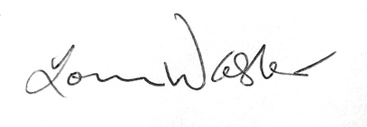

Louise Washer, President
Norwalk River Watershed Association

